**An Introduction to HTML**

**Overview**

HTML stands for **HyperText Markup Language** and is one of the three core technologies of the web, HTML, CSS, and JavaScript. HTMl defines the structure of a document. Hypertext refers to the way we can place hypertext links in our document that allows our users to move from one page to another. Markup is a set of symbols or codes for displaying content on the Internet. Web browsers use HTML markup and content to render pages.

"HTML (HyperText Markup Language) is the most basic building block of the Web. It defines the meaning and structure of web content. Other technologies besides HTML are generally used to describe a web page's appearance/presentation (CSS) or functionality/behavior (JavaScript)." - MDN (Mozilla Developer Network Reference)

**Prepare**

Prepare for the assignment by carefully pondering, noting, and referencing the materials provided.

* Watch: 🎦 [Web Development Basics](https://www.youtube.com/embed/HTsJbDw13tI) - (4:32 mins, 📄 [Transcript](https://byui-wdd.github.io/wdd130/text/webdev_basics.pdf))
* Watch: 🎦 [What is HTML?](https://www.youtube.com/embed/jxYtjiuPfLQ) - (3:25 mins, 📄 [Transcript](https://byui-wdd.github.io/wdd130/text/what_is_html.pdf))
* Watch: 🎦 [HTML Elements and Attributes](https://youtu.be/GpZmiD8WlFo) - (5:52 mins, 📄 [Transcript](https://byui-wdd.github.io/wdd130/text/beg_html_elements.pdf))

**Activity Instructions**

In this activity, answer the following questions about HTML and ponder the provided solutions.

1. The following HTML elements are **required** for every HTML document created in this course.  
   What is the purpose of each of the following HTML elements?
   * <!DOCTYPE html>

Answer

"It is a required preamble. In the mists of time, when HTML was young (around 1991/92), doctypes were meant to act as links to a set of rules that the HTML page had to follow to be considered good HTML, which could mean automatic error checking and other useful things. However, these days, they don't do much and are basically just needed to make sure your document behaves correctly. That's all you need to know for now." - MDN

☑️ This is a required, development checklist item for all HTML documents produced in this course.

* + <html lang="en-US"> ... </html>

Answer

"This element wraps all the content on the entire page and is sometimes known as the root element. It also includes the **lang** attribute, setting the primary language of the document." - MDN

☑️ This is a required, development checklist item and must include the lang attribute.

* + <head> ... </head>

Answer

"The **head** HTML element contains machine-readable information (metadata) about the document, like its character support, viewport sizing, title, scripts, and style sheets." - MDN

☑️ This is a required, development checklist item.

* + <meta charset="utf-8">

Answer

Located within the <head> element. "This attribute declares the document's character encoding. If the attribute is present, its value must be an ASCII case-insensitive match for the string "utf-8", because UTF-8 is the only valid encoding for HTML5 documents. <meta> elements which declare a character encoding must be located entirely within the first 1024 bytes of the document." - MDN

☑️ This is a required, development checklist item.

* + <meta name="viewport" content="width=device-width,initial-scale=1.0">

Answer

Located within the <head> element. "This viewport element ensures the page renders at the width of viewport, preventing mobile browsers from rendering pages wider than the viewport and then shrinking them down." - MDN

☑️ This is a required, development checklist item.

* + <title>...</title>

Answer

Located within the <head> element. "This sets the title of your page, which is the title that appears in the browser tab of the page. It is also used to describe the page when you bookmark/favorite it." - MDN

The content of the title should closely match the content of the heading 1 <h1> element in the document <body>.

☑️ This is a required, development checklist item and must be relevant to the document.

* + <body> ... </body>

Answer

"The <body> HTML element represents the content of an HTML document. There can be only one body element in a document. It contains all the content that you want to show to web users when they visit your page, whether that's text, images, videos, games, playable audio tracks, or whatever else." - MDN

☑️ This is a required, development checklist item.

1. What is the basic anatomy of an HTML document that is required for all pages in this course?

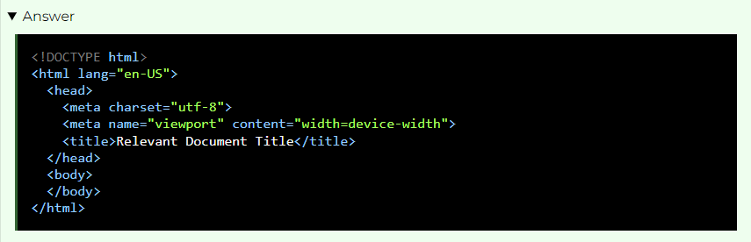

1. Using the following example HTML snippet of code, technically **name** the numbered parts:

<p>A paragraph containing a hyperlink to <a href="https://www.byui.edu">BYU-Idaho</a>.</p>

* + **<p>**
  + **</p>**
  + **href**
  + A paragraph containing a hyperlink to [BYU-Idaho](https://www.byui.edu/).
  + The entire snippet.

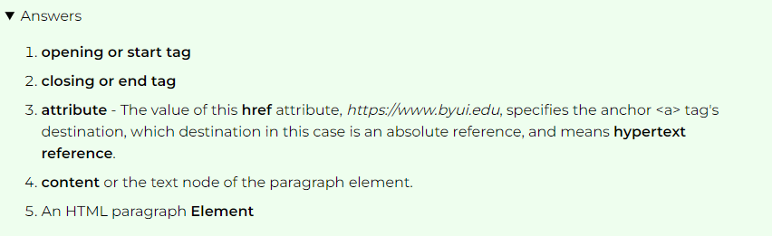

1. Some elements have no content and no closing tag. They are called _______ or self-closing tags.

An example element of this type is an image **<img>** element.Answer





**Optional Resources**

* [HTML: HyperText Markup Language](https://developer.mozilla.org/en-US/docs/Web/HTML) - MDN (Mozilla Dev Network)
* [HTML Basics](https://developer.mozilla.org/en-US/docs/Learn/Getting_started_with_the_web/HTML_basics) - MDN
* [HTML Basic Document Anatomy](https://developer.mozilla.org/en-US/docs/Learn/Getting_started_with_the_web/HTML_basics#anatomy_of_an_html_document) - MDN
* [doctype](https://developer.mozilla.org/en-US/docs/Glossary/Doctype) - MDN
* [The lang attribute](https://developer.mozilla.org/en-US/docs/Web/HTML/Global_attributes#lang) - MDN